Olist E-Commerce Data Analysis

Data Analysis and Visualization using Power BI


Project Summary

An end-to-end data analytics project analyzing the Olist Brazilian e-commerce marketplace. The project focused on understanding sales performance, customer behavior, product categories, and delivery operations. Data was cleaned and validated using Excel, analyzed using PostgreSQL/SQL and Python, and transformed into an interactive Power BI dashboard to identify business trends, performance gaps, and actionable insights.

Business Problem & Objectives

Business Problem

Olist operates a large e-commerce marketplace connecting customers and sellers across Brazil. With a large volume of orders, products, customers, and delivery records, analyzing this data can help identify patterns in sales performance, customer behavior, product demand, and delivery operations.

The objective of this project was to analyze Olist's historical e-commerce data and turn it into meaningful business insights that could support better decision-making.

Project Objectives

The analysis focused on four key areas:
- Sales & Revenue Performance
  - Analyze total sales, order volume, average order value, and sales by category and customer state.
  - Identify the strongest-performing product categories and regions.
- Customer Behavior
  - Understand customer acquisition and repeat purchasing behavior.
  - Analyze the number of unique customers, repeat customers, and average orders per customer.
  - Identify differences in customer behavior across Brazilian states.
- Delivery Operations
  - Measure delivery performance and identify late deliveries.
  - Analyze average delivery time and late-delivery rates across product categories and over time.
  - Identify areas where delivery performance could be improved.
- Business Recommendations
  - Use the analysis to identify opportunities to improve customer retention, sales performance, and delivery operations.
  - Translate the findings into practical business recommendations.

Data Sources

The analysis was based on the Olist Brazilian E-commerce Dataset, which contains information about orders, customers, products, product categories, sellers, and order items.

The main datasets used in the project were:
- Orders Dataset — order IDs, customer IDs, order status, purchase dates, approval dates, delivery dates, and estimated delivery dates.
- Order Items Dataset — products purchased within each order, sellers, product prices, and freight values.
- Products Dataset — product IDs and product category information.
- Customers Dataset — customer IDs, unique customer IDs, and customer states.
- Product Category Translation Dataset — used to translate Portuguese product category names into English.

Tools Used
Tool | Purpose
Excel | Data cleaning, category translation, duplicate checks, and data-quality validation
PostgreSQL / SQL | Data extraction, analysis, aggregations, and business-focused queries
Python / Pandas | Additional data analysis and customer/cohort analysis
Power BI | Interactive dashboard creation, KPIs, visualizations, filtering, and business insights

Analysis Approach

The project followed an end-to-end analytics workflow:

Raw Data → Cleaning & QA → SQL Analysis → Python Analysis → Power BI → Business Insights & Recommendations

This approach allowed the data to be validated before analysis and then transformed into an interactive dashboard for business decision-making.

Cleaning Data and Exploratory Data Analysis
I started with the raw Olist datasets:
- olist_orders_dataset
- olist_order_items_dataset
- olist_products_dataset
- olist_customers_dataset
- product_category_name_translation
The orders dataset originally contained:
order_id, customer_id, order_status, order_purchase_timestamp, order_approved_at, order_delivered_carrier_date, order_delivered_customer_date, order_estimated_delivery_date
The order items dataset contained:
order_id, order_item_id, product_id, seller_id, shipping_limit_date, price, freight_value
The products dataset contained:
product_id, product_category_name, product_name_lenght, product_description_lenght, product_photos_qty, product_weight_g, product_length_cm, product_height_cm, product_width_cm
And the customer dataset contained:
customer_id and customer_unique_id, among other customer/location fields.
One of the first major cleaning problems I encountered was timestamp problem. The Olist date columns weren't initially in a format that Power BI was interpreting correctly.
We encountered values such as:
02-10-2017 10.56
19-09-2017 9.45.35 AM
The solution was to transform the timestamp fields so they could be properly interpreted as Date/Time.
The important order timestamps were:
- order_purchase_timestamp
- order_approved_at
- order_delivered_carrier_date
- order_delivered_customer_date
- order_estimated_delivery_date
After cleaning/parsing them, Power BI could properly use them for:
- month analysis
- delivery calculations
- date comparisons
- time-based charts
- delivery performance analysis
After fixing the timestamp we checked for missing values or duplicates. The raw dataset initially appeared to have roughly 9.5% missing values across many columns, because of the way the data had initially been imported/handled.
After cleaning, the actual missing values were much smaller:
Column | Missing
order_id | 0
customer_id | 0
order_status | 0
order_purchase_timestamp | 0
order_approved_at | 160
order_delivered_carrier_date | 1783
order_delivered_customer_date | 2,965
order_estimated_delivery_date | 0
I did not delete the rows containing missing dates because I did not enough evidence to make that kind of deletion. For example, an order that wasn't delivered yet or was canceled may naturally have no customer-delivery date. Such kind of decisions requires proper evidence or further investigation.
Then I observed the timestamps while performing EDA and realized that I need to filter out the dates and create a month-level field which will help me analyze the purchases by month so I created purchase_month column from order_purchase_timestamp.
The pandas code for purchase_month is:
orders = pd.read_csv("data/olist_orders_dataset.csv")
orders["purchase_month"] = orders["order_purchase_timestamp"].dt.strftime("%Y-%m")
Then I moved into delivery analysis and calculated the amount of time between the relevant order/delivery dates. This led to the creation of columns delivery_time and delivery_days.
delivery_days became the numeric field we could use for average delivery time, delivery performance, comparing categories, comparing sellers and identifying late orders.
The final average delivery time we calculated was 12.09 days.
The code for delivery_time and DAX formula for delivery_days are:
orders["delivery_time"] = (
orders["order_delivered_customer_date"] - orders["order_purchase_timestamp"]
)
The DAX formula for delivery_days is:
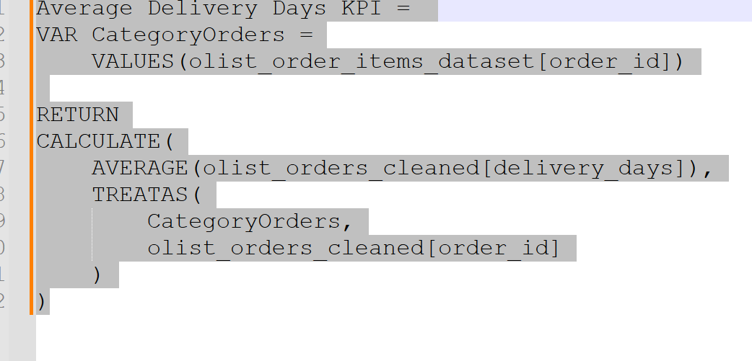

Then I decided to classify the purchase orders in three categories:
- On Time/Early – To check whether the delivery was on or before the estimated delivery date.
- Late - To check whether the delivery was after the estimated delivery date.
- Cannot Check – For these there was not enough info determine the cause whether the order was late.
To classify the orders, I had to compare actual customer delivery date against estimated delivery date so I created delivery_status column.
The pandas code for delivery_status is:
def classify_delivery(actual, estimated):
if pd.isna(actual):
return "Cannot Check"
elif actual > estimated:
return "Late"
else:
return "On Time/Early"
orders["delivery_status"] = orders.apply(
lambda row: classify_delivery(
row["order_delivered_customer_date"],
row["order_estimated_delivery_date"]
),
axis=1
)
After the transformations and EDA I finally created olist_orders_cleaned dataset and established relationships with other datasets.
Here’s the final model showing the relationships:
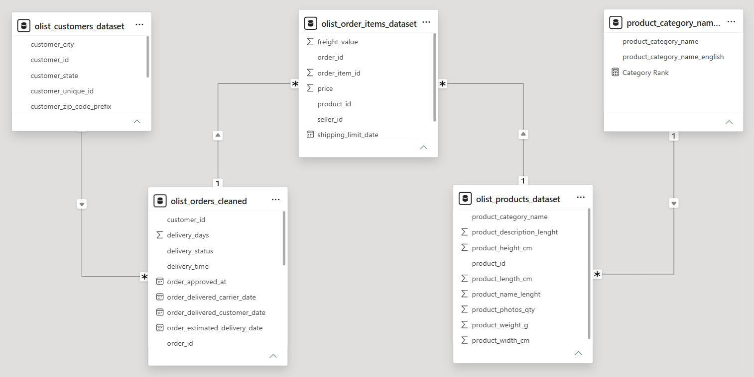

Analyze
Delivery Operations Dashboard
In the delivery operations section, I want to show the average delivery days, on time/early rate, late deliveries, and late delivery rate. All of these measures will be shown in cards.
I inserted a bar chart to show the top 10 products category by late delivery rate.
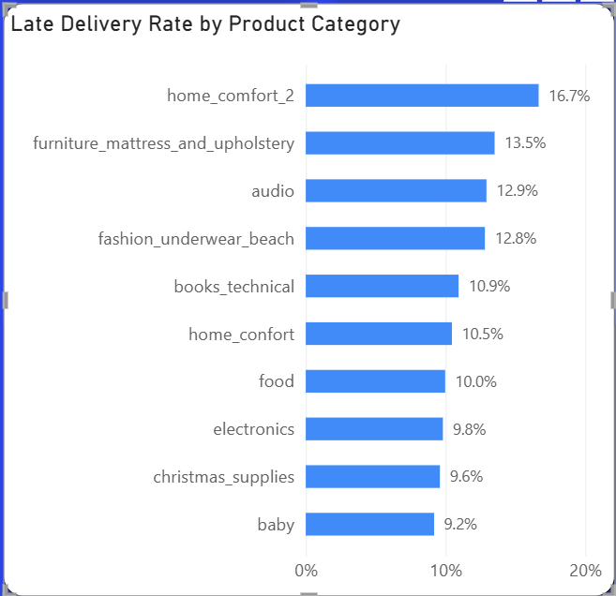
The home_comfort_2 category is in the top with a late delivery rate of 16.7%.
Then I made another bar chart, where I want to show the top 10 product categories by average delivery time in days.
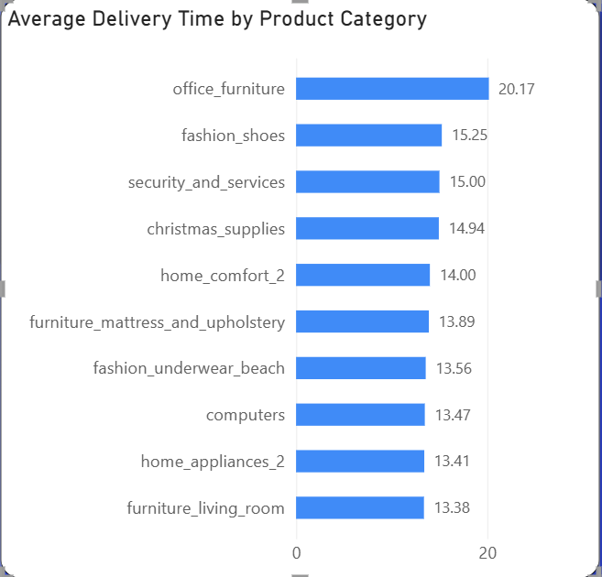

The office_furniture category is in the top with average delivery time of 20.17 days.

Then I added a donut chart which shows delivery performance and breaks down the total deliveries in three sections: On Time/Early, Late and Cannot Check.

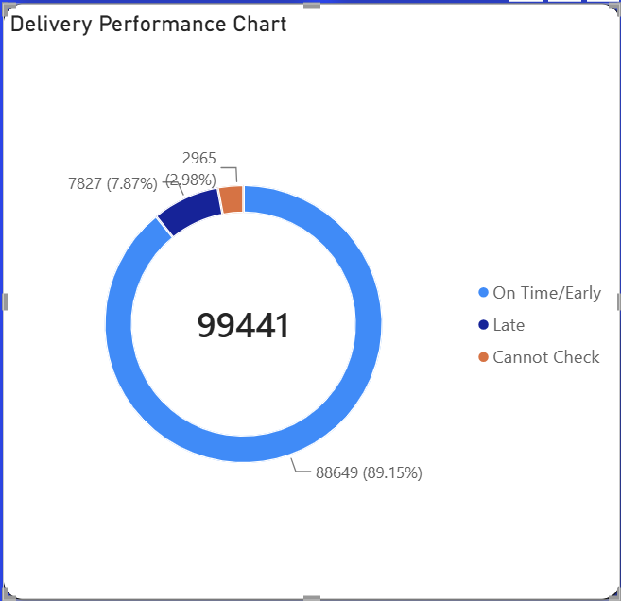

The legend is using delivery_status column I made with pandas code which is used for the breakdown.

As per this chart out of the total orders of 99441 , 89.15% orders (88649) were delivered on time or earlier, 7.87% orders (7827) were delivered late and 2.98% orders (2965) cannot be verified due to incomplete information. Further investigation is required to determine the cause.

Note:- The percentages shown for On Time/Early in Delivery Performance Chart (89.15%) and On Time/Early Rate card (91.89%) are different because both are calculating different things.
- Delivery Performance Chart is calculating on time percentage based on the overall delivery performance result which also includes cannot check orders percentage.
- On Time/Early Rate card is calculating on time percentage based on the delivery performance result that can be evaluated. So it looks like this :
91.89 % = 88,649 ÷ (88,649 + 7,827) * 100
This is the reason the percentages differ in both the chart and the card.

And finally I decided to add a line chart to show delivery performance over time by late delivery rate.

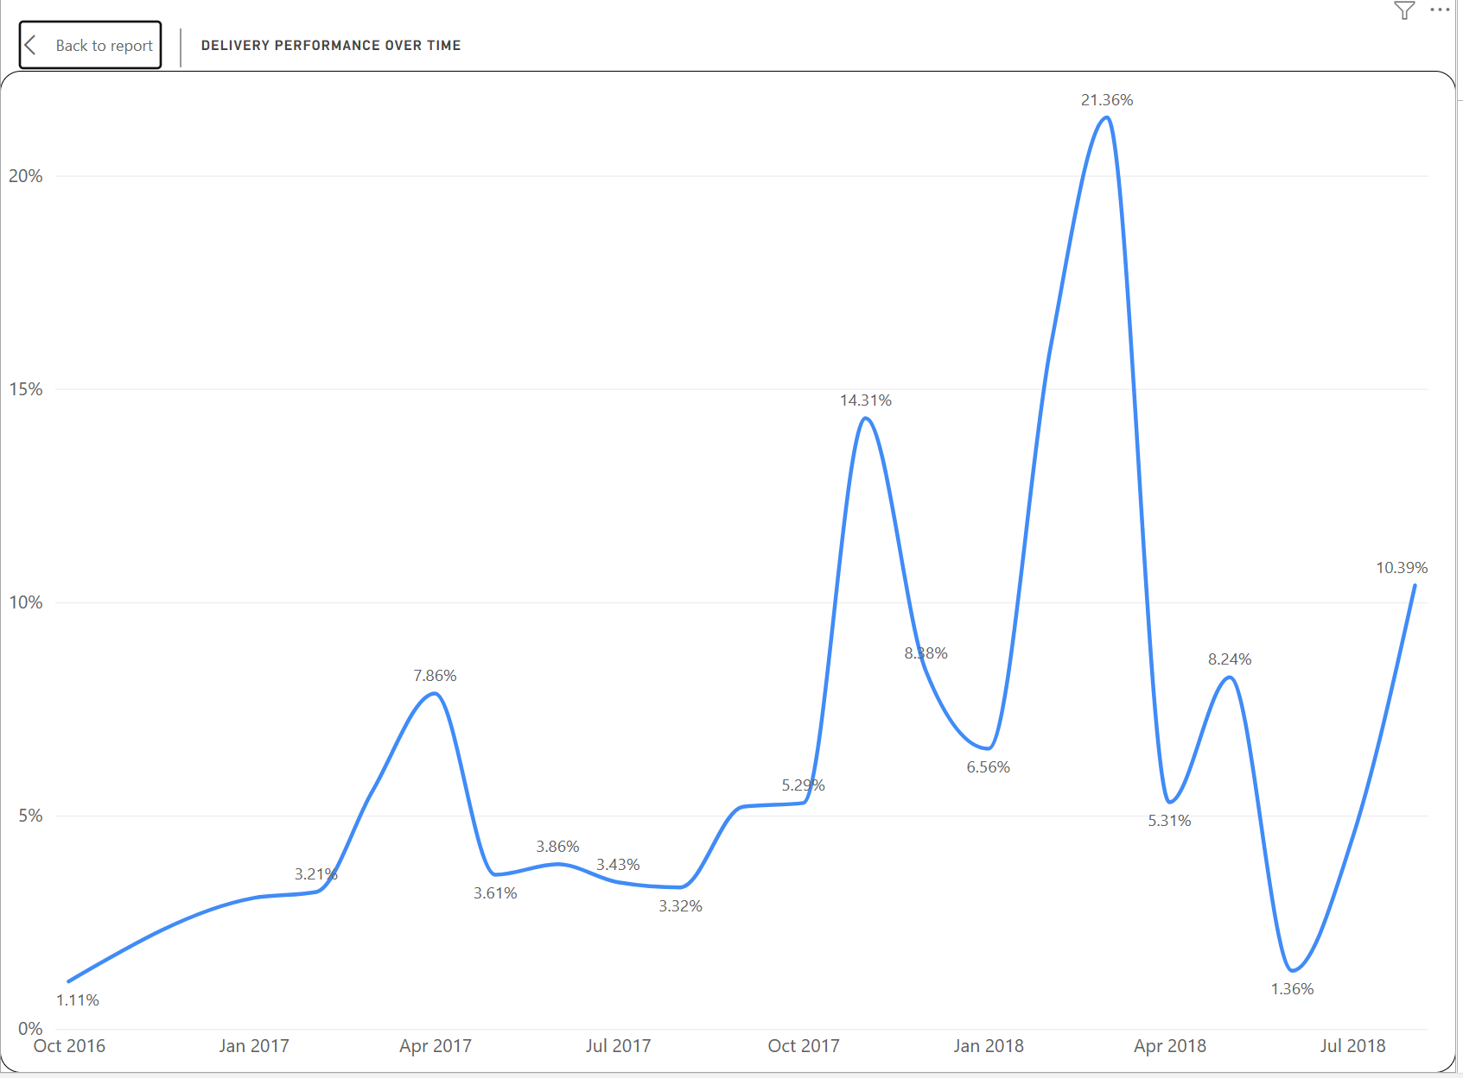

According to this chart, March 2018 had the highest late delivery rate of 21.36% across 7003 checkable orders and October 2016 had the lowest late delivery rate of 1.11% across 270 checkable orders. Needs further investigation to determine the cause for higher late delivery rate.

The DAX measure I need to get late delivery rate by product category is:
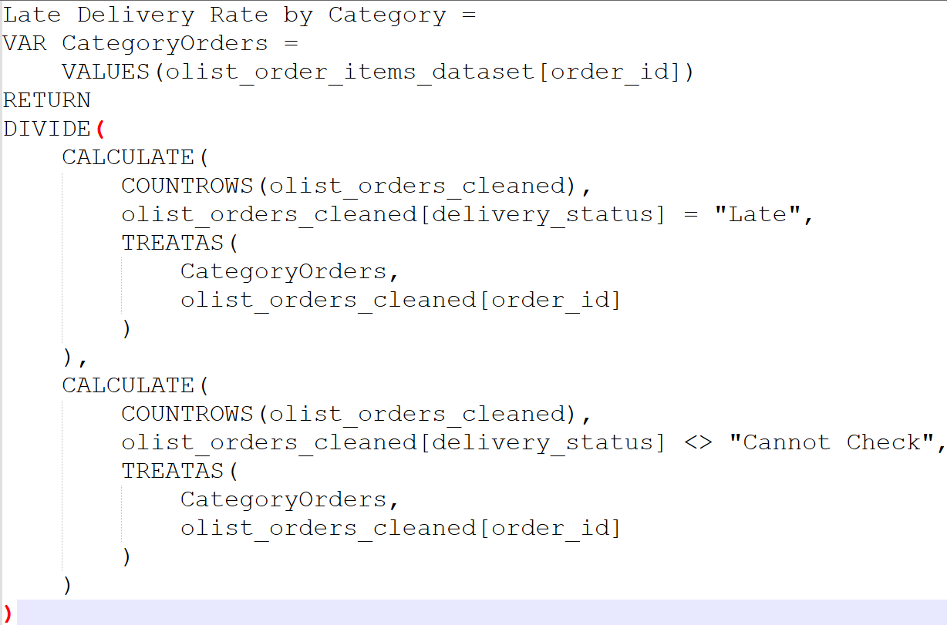

The DAX measure I need to get average delivery days by product category is:
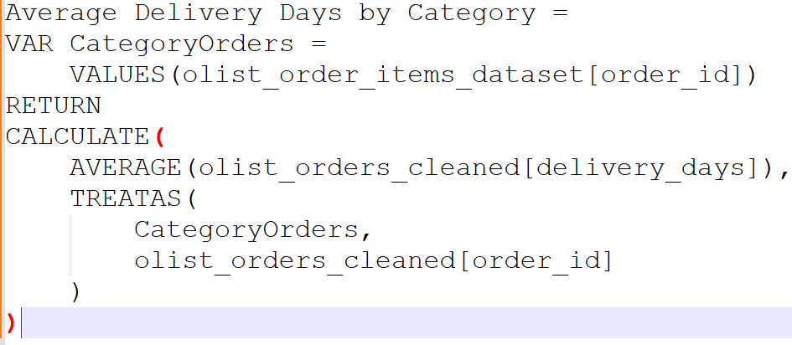

The DAX measure I need to get late delivery rate over time is:
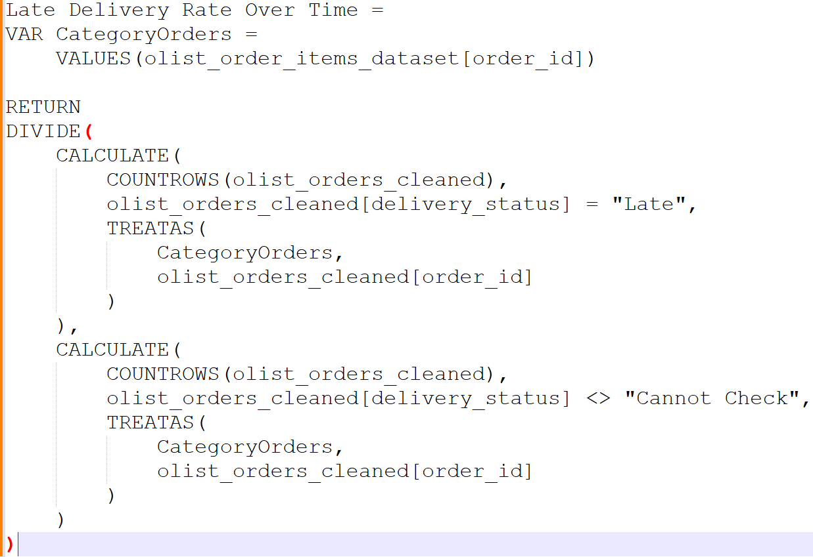

After getting the required measures, I added cards that will show the number of average delivery days, on time/early rate(evaluable orders), late deliveries, and late delivery rate.
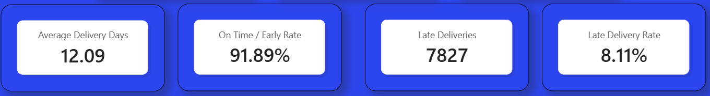

I created slicers to filter product category, customer state, and purchase month with a button to clear all filters.
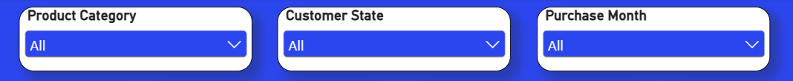
Customer Insights Dashboard
For the customer insights dashboard, I inserted cards to show the total customers, repeat customers and average orders per customer.
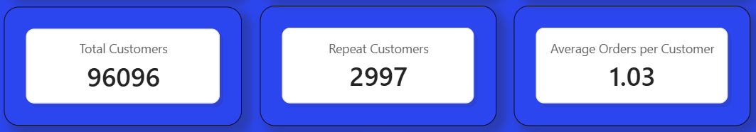
Next, I added a column chart to show new customers vs repeat customers ratio by month.
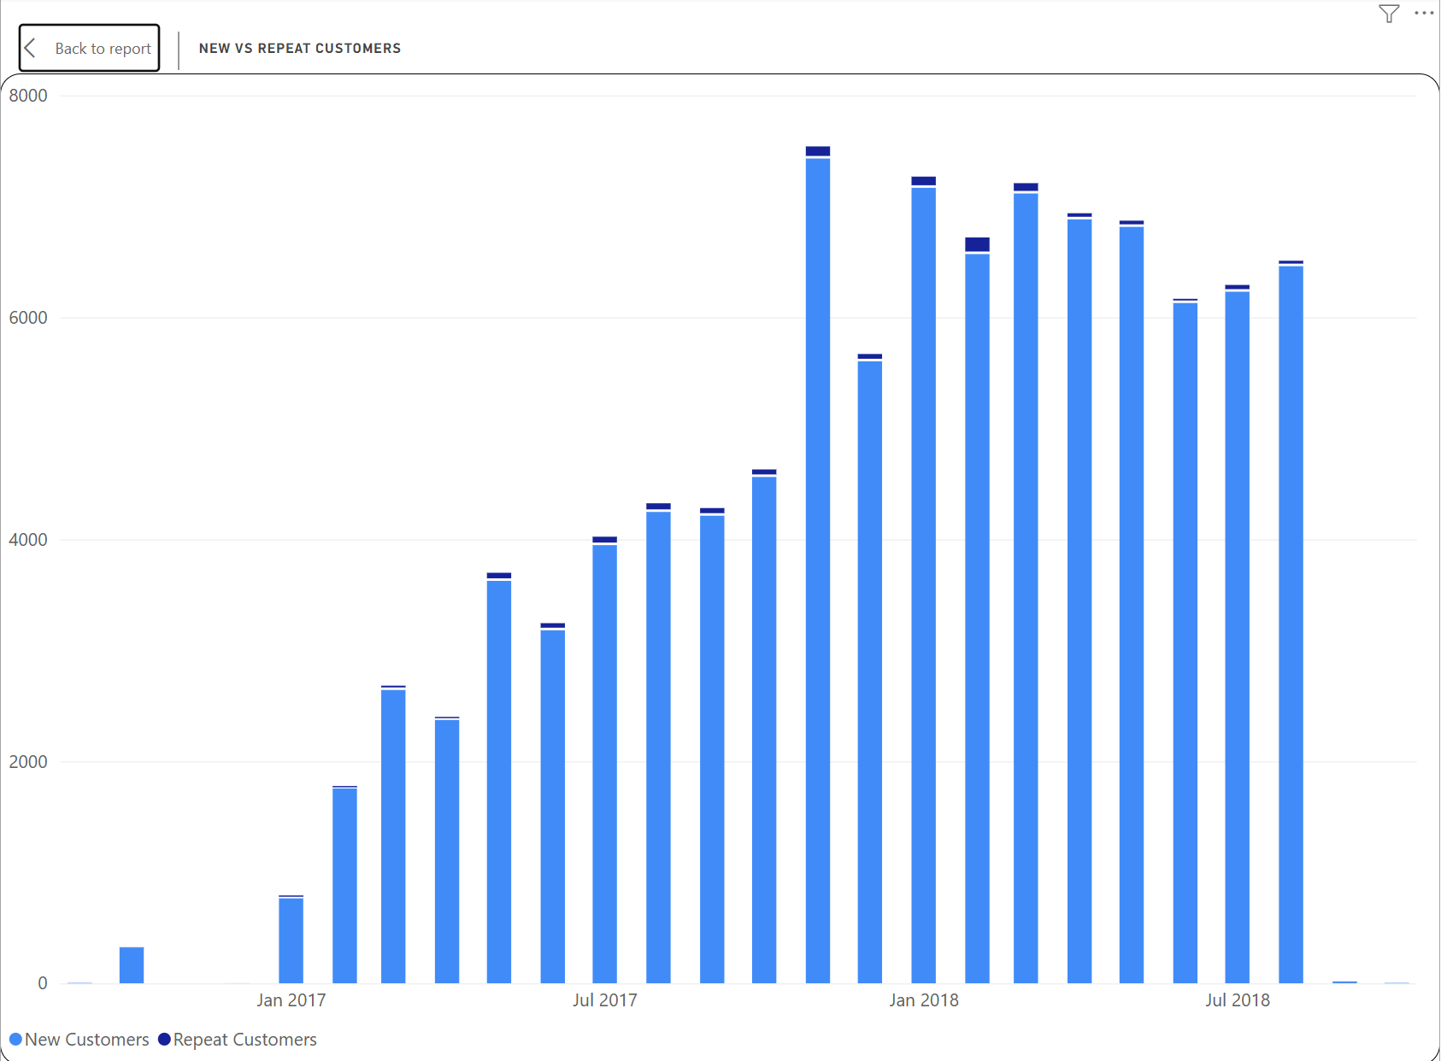
Line chart to show average order value by month.
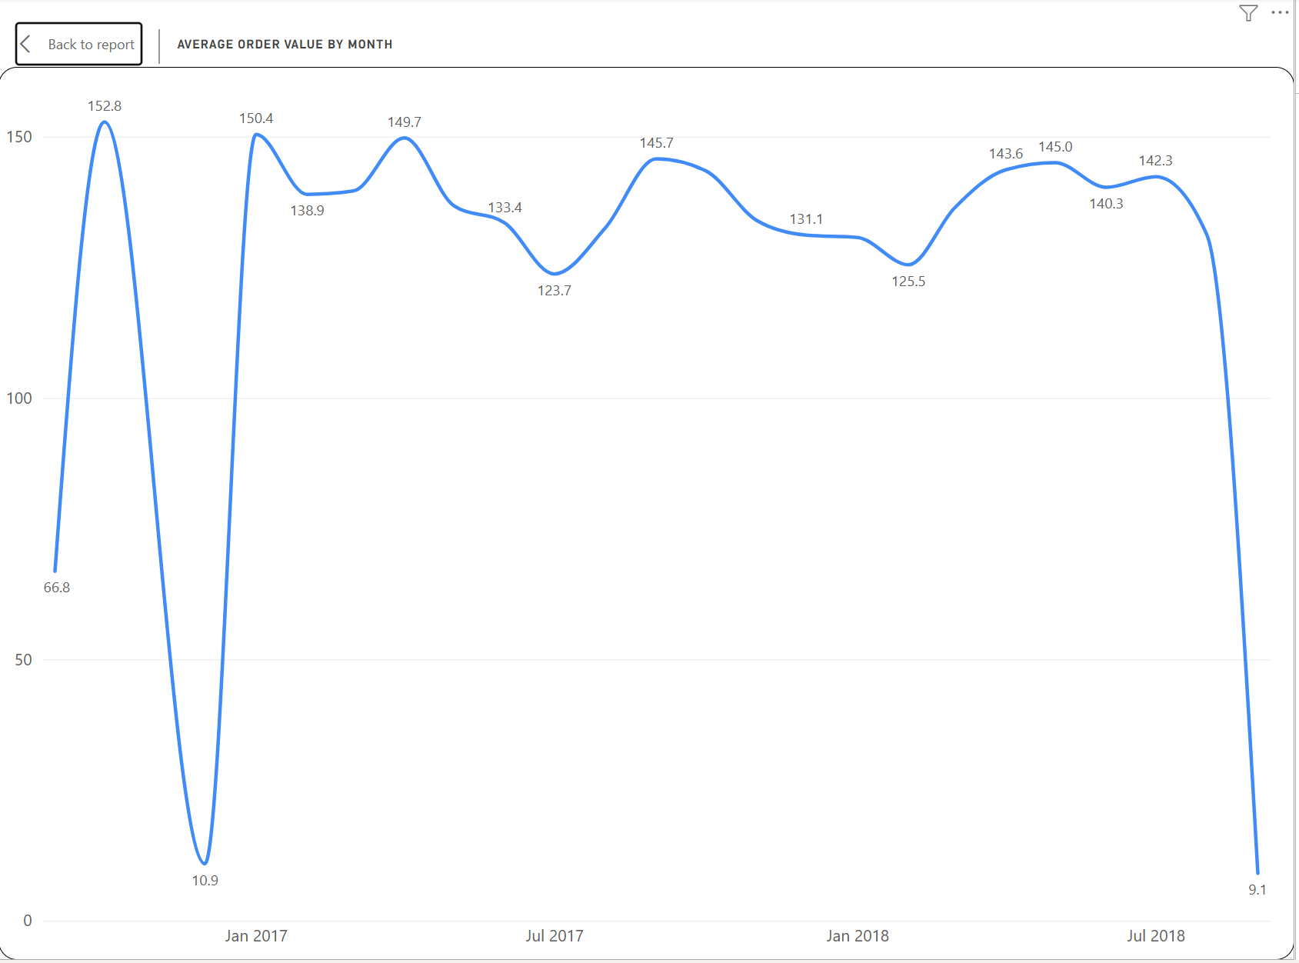
Bar chart to show top 10 states by order count.
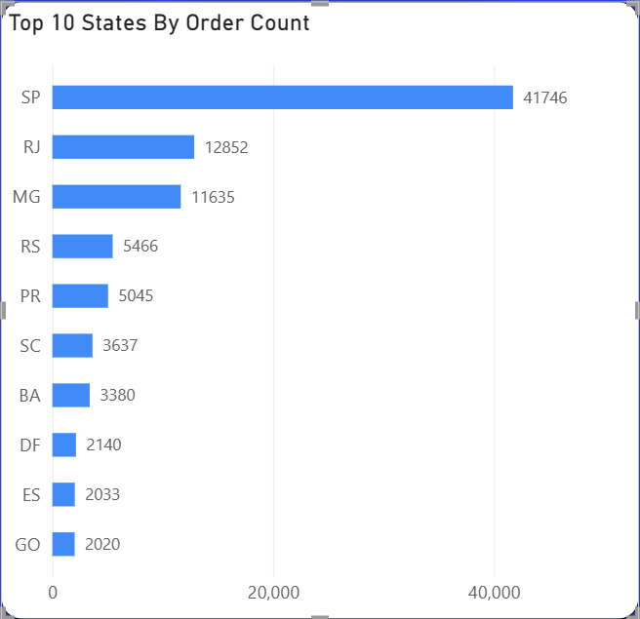

Sales and Revenue Performance Dashboard
For the sales and revenue performance dashboard, I inserted cards to show the total sales, total orders, total items sold, and average order value.
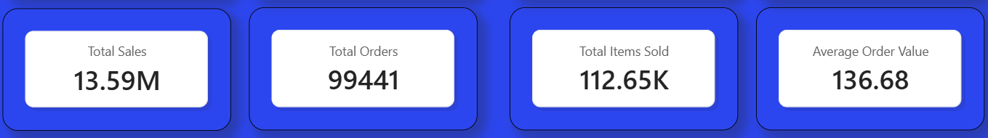

Next I created slicers to filter product category, customer state, purchase month and order status with a button to clear all filters.

Next I added bar chart to show top 10 sales by customer state.
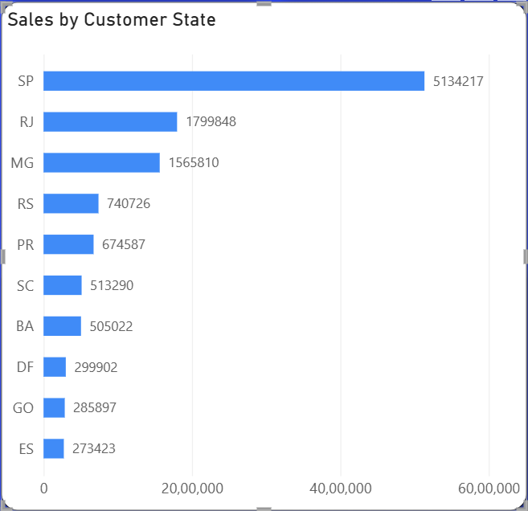

Bar chart for top 10 sales by product category.
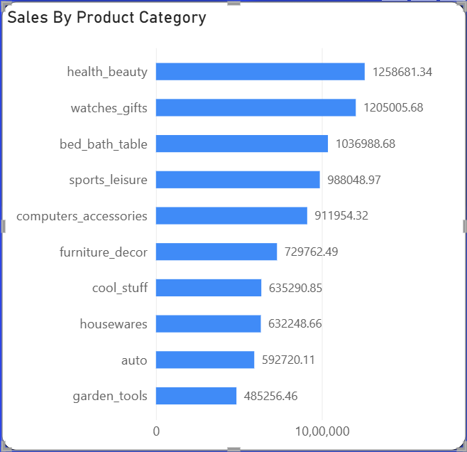

Bar chart for sales value by order status.
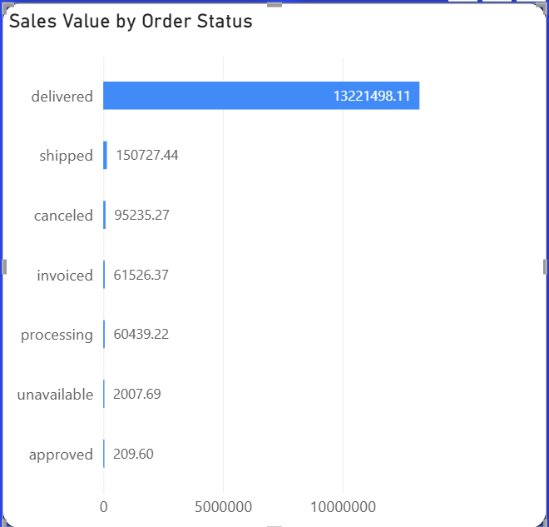

Overview
Delivery Operations Dashboard
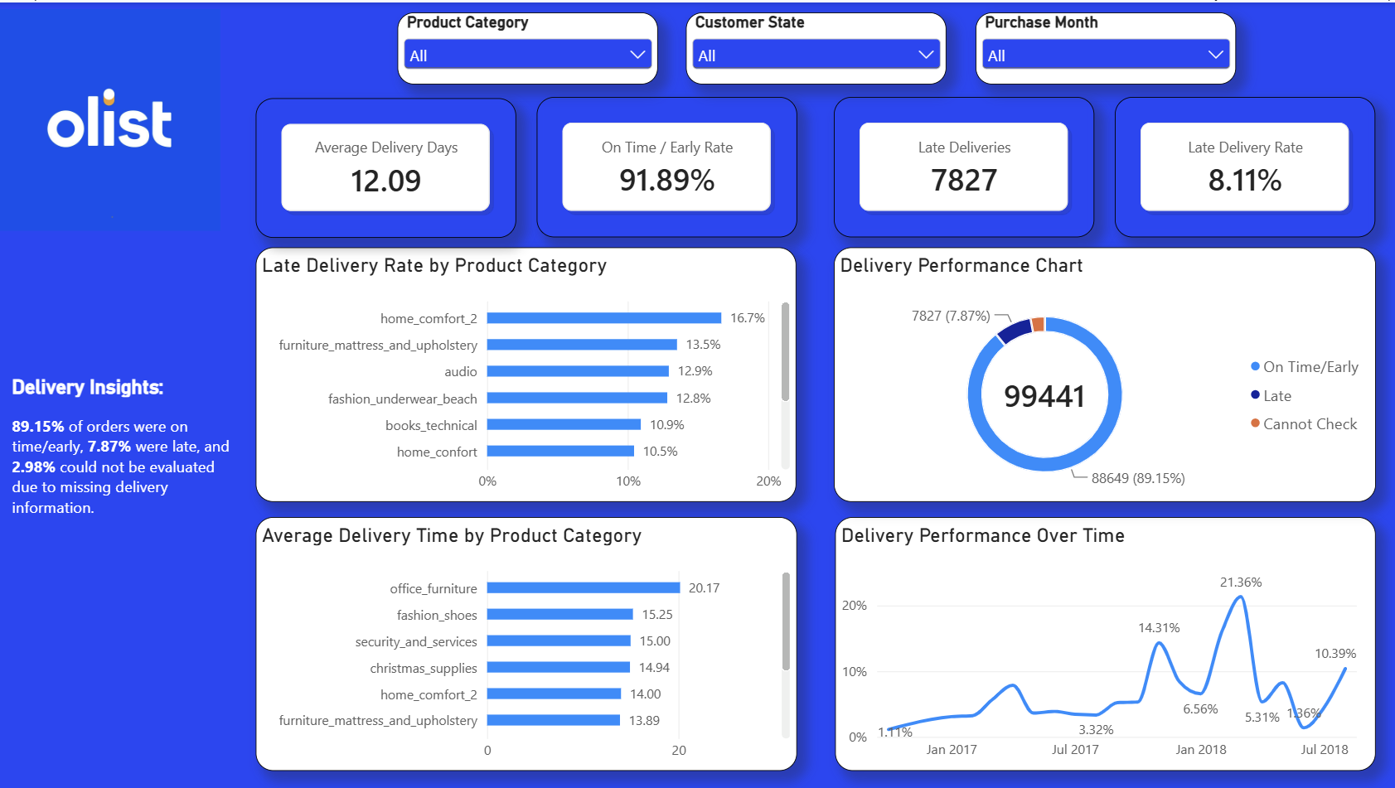
Customer Insights Dashboard
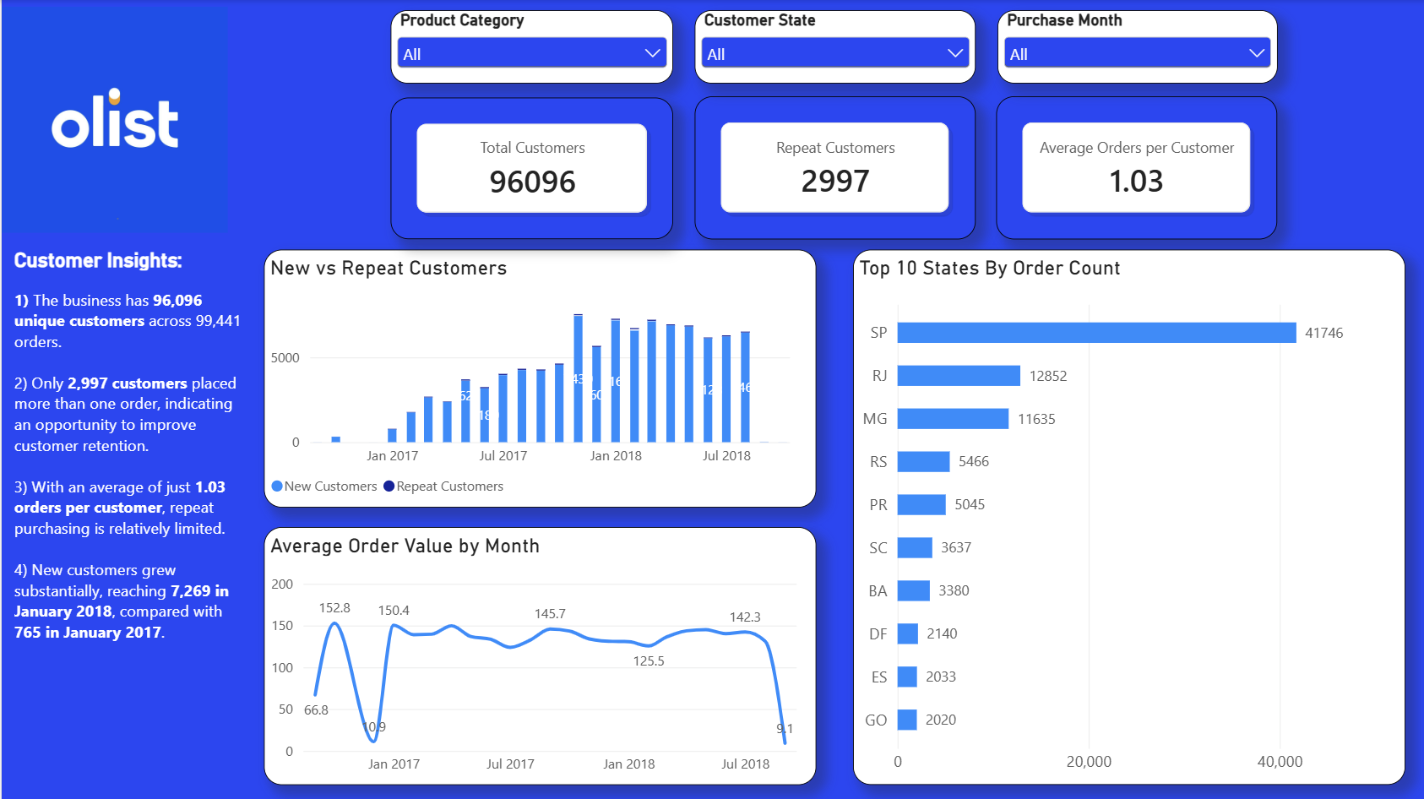
Sales & Revenue Performance Dashboard
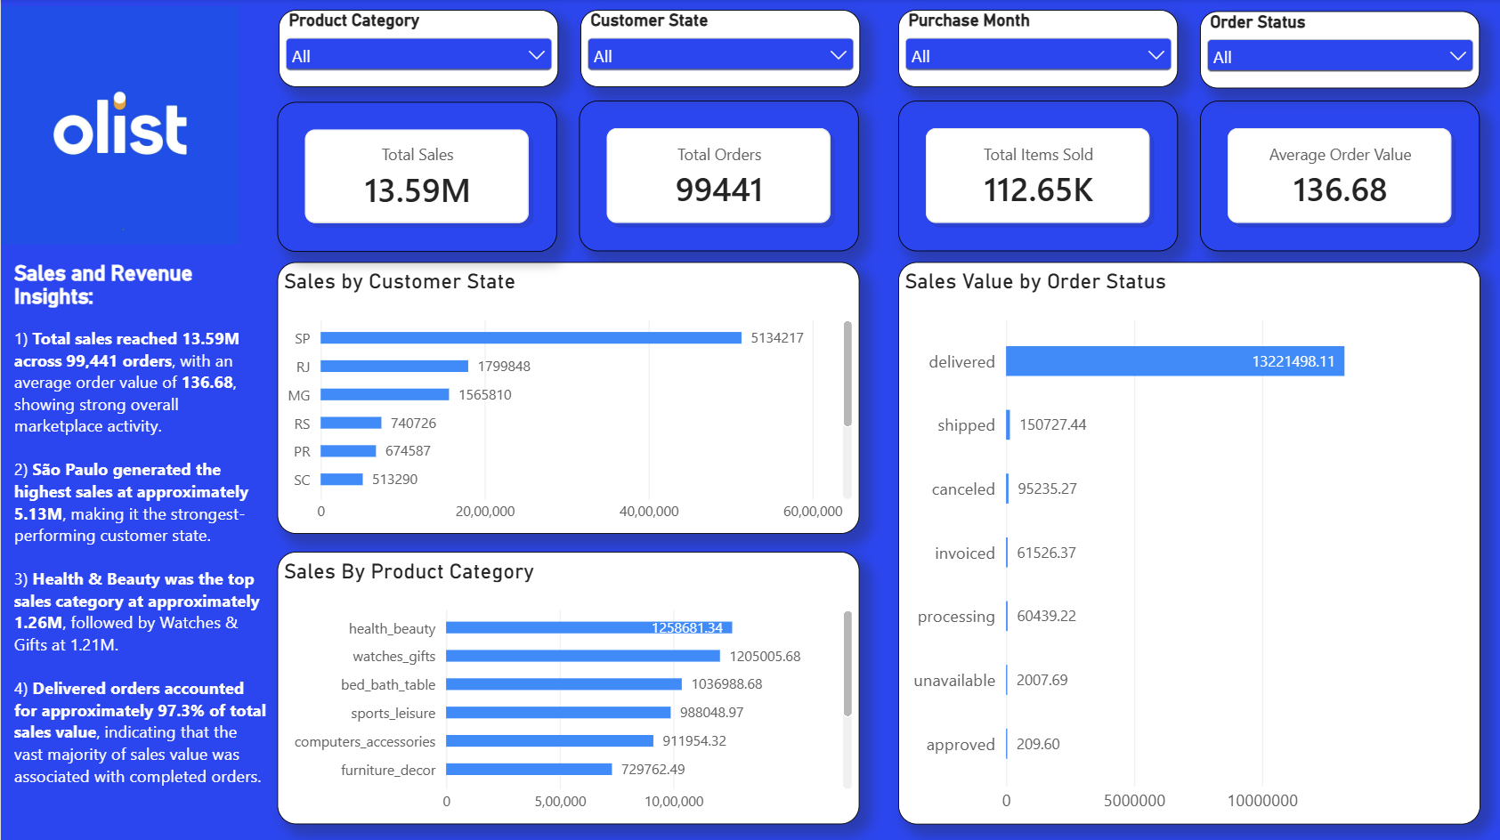

INSIGHTS
1) 89.15% of orders were on time/early, 7.87% were late, and 2.98% could not be evaluated due to missing delivery information.
2) The business has 96,096 unique customers across 99,441 orders.
3) Only 2,997 customers placed more than one order, indicating an opportunity to improve customer retention.
4) With an average of just 1.03 orders per customer, repeat purchasing is relatively limited
5) New customers grew substantially, reaching 7,430 in November 2017, compared with 765 in January 2017.
6) Total sales reached 13.59M across 99,441 orders, with an average order value of 136.68, showing strong overall marketplace activity.
7) São Paulo generated the highest sales at approximately 5.13M, making it the strongest-performing customer state.
8) Health & Beauty was the top sales category at approximately 1.26M, followed by Watches & Gifts at 1.21M.
9) Delivered orders accounted for approximately 97.3% of total sales value, indicating that the vast majority of sales value was associated with completed orders.

RECOMMENDATIONS
1) Introduce customer retention strategies such as personalized offers, post-purchase communication, and incentives for a second purchase to increase repeat ordering.
2) Investigate the main causes of late deliveries and prioritize improvements in periods, categories, and operational areas with consistently higher delay rates.
3) Use historical demand patterns to plan inventory, fulfillment capacity, and delivery resources ahead of high-demand periods.
4) Prioritize high-revenue categories for inventory availability and targeted promotions while monitoring their delivery performance to protect sales and customer satisfaction.
5) Prioritize logistics, inventory availability, and customer initiatives in major markets such as São Paulo while using their performance as a benchmark for other regions.

